SS11 Chapter 11: Population Name:___________________________
Independent Thinking and opinion questions: Read about the attempts of the Indian and Chinese governments to limit their surging populations p. 368
- Describe China’s One Child Policy (when, what, how, rules, incentives).
________________________________________________________________________
________________________________________________________________________
________________________________________________________________________
________________________________________________________________________
________________________________________________________________________
________________________________________________________________________
- Compare/contrast China’s approach to population control to India’s (5-8points)
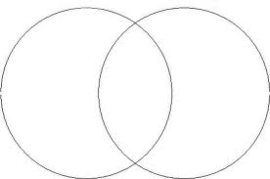
- Do you prefer one country’s approach over the other? Please explain.
________________________________________________________________________
________________________________________________________________________
________________________________________________________________________
________________________________________________________________________
________________________________________________________________________
- To what extent do you think India and China’s attempts at population control were successful? Give reasons to support your opinion.
________________________________________________________________________
________________________________________________________________________
________________________________________________________________________
________________________________________________________________________
________________________________________________________________________
________________________________________________________________________
________________________________________________________________________
________________________________________________________________________
________________________________________________________________________
________________________________________________________________________
________________________________________________________________________

