Socials 11: Trudeau and the 1970’s Political Cartoon Analysis
Cartoons from: http://edocs.lib.sfu.ca/projects/Cartoons/

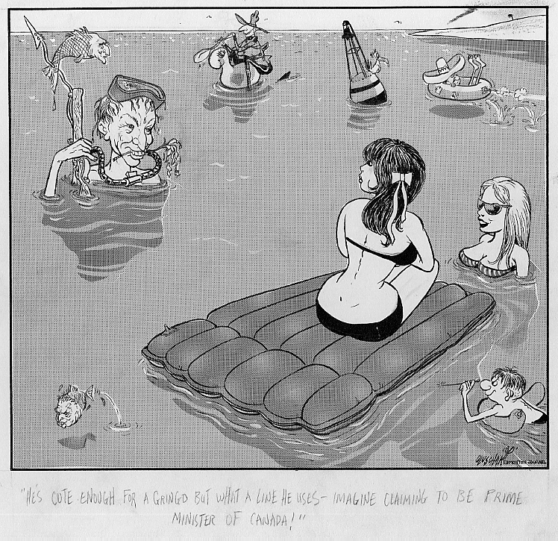
Text: “He’s cute enough for a gringo but what a line he uses – imagine claiming to be Prime Minister of Canada!”
Cartoonist: Uluschak, Edd
Date on cartoon: December 30, 1970
Published in: Edmonton Journal

1. What is the event or issue that inspired the cartoon?

2. Suggest one or two adjectives to describe the personality that the cartooned individual’s appearance suggests.

3. Make notes of the characters and symbols represented in the cartoon.

4. Identify the specific artistic techniques used in the cartoon (i.e., symbolism, analogy, exaggeration, labeling, and irony). What is the artist trying to show the reader by using these techniques?

5. What is the author’s attitude towards the subject matter? (approving, stereotypical, nationalistic, sexist, ironic, respectful, etc.)

6. What is the cartoonist's point of view about the topic portrayed in the cartoon? Give examples to support your interpretation.

7. Is this cartoon persuasive? Explain why or why not.

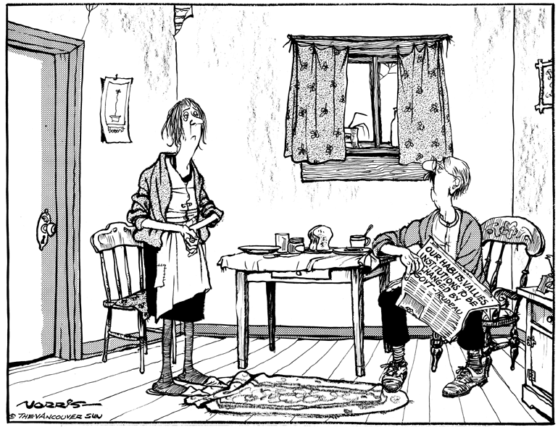

Text: "It means we'll have no more helicopter picnics, trips to Europe, pool-side parties, vacations in the Caribbean, skiing at winter spas ..."
Cartoonist: Norris, Len
Date on cartoon: December 30, 1975
Published in: Vancouver Sun

1. What is the event or issue that inspired the cartoon?

2. Suggest one or two adjectives to describe the personality that the cartooned individual’s appearance suggests.

3. Make notes of the characters and symbols represented in the cartoon.

4. Identify the specific artistic techniques used in the cartoon (i.e., symbolism, analogy, exaggeration, labeling, and irony). What is the artist trying to show the reader by using these techniques?

5. What is the author’s attitude towards the subject matter? (approving, stereotypical, nationalistic, sexist, ironic, respectful, etc.)

6. What is the cartoonist's point of view about the topic portrayed in the cartoon? Give examples to support your interpretation.

7. Is this cartoon persuasive? Explain why or why not.

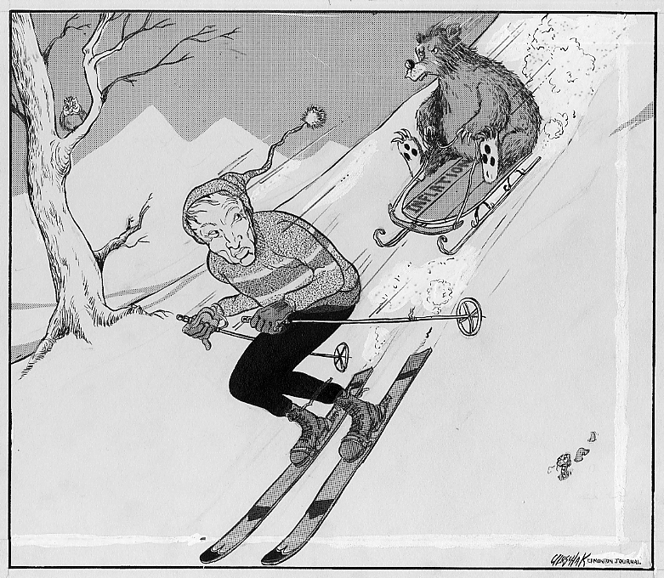

Text:(no text)
Cartoonist:Uluschak, Edd
Date on cartoon:January 8, 1970
Published in:Edmonton Journal

1. What is the event or issue that inspired the cartoon?

2. Suggest one or two adjectives to describe the personality that the cartooned individual’s appearance suggests.

3. Make notes of the characters and symbols represented in the cartoon.

4. Identify the specific artistic techniques used in the cartoon (i.e., symbolism, analogy, exaggeration, labeling, and irony). What is the artist trying to show the reader by using these techniques?

5. What is the author’s attitude towards the subject matter? (approving, stereotypical, nationalistic, sexist, ironic, respectful, etc.)

6. What is the cartoonist's point of view about the topic portrayed in the cartoon? Give examples to support your interpretation.

7. Is this cartoon persuasive? Explain why or why not.

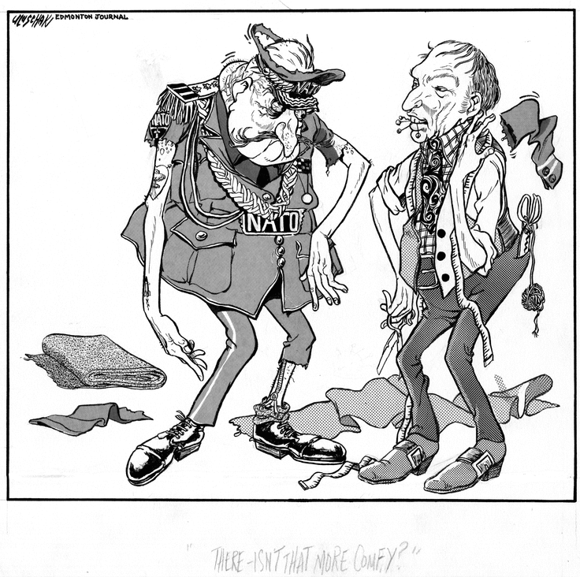

Text: "There - isn't that more comfy?"
Cartoonist: Uluschak, Edd
Date on cartoon: January 1, 1969
Published in: Edmonton Journal

1. What is the event or issue that inspired the cartoon?

2. Suggest one or two adjectives to describe the personality that the cartooned individual’s appearance suggests.

3. Make notes of the characters and symbols represented in the cartoon.

4. Identify the specific artistic techniques used in the cartoon (i.e., symbolism, analogy, exaggeration, labeling, and irony). What is the artist trying to show the reader by using these techniques?

5. What is the author’s attitude towards the subject matter? (approving, stereotypical, nationalistic, sexist, ironic, respectful, etc.)

6. What is the cartoonist's point of view about the topic portrayed in the cartoon? Give examples to support your interpretation.

7. Is this cartoon persuasive? Explain why or why not.

